5-NEIGHBOR

The purpose of this module is to simulate the interaction between trees in the cohorts and stand grid cells regarding light. The main spatial interaction between trees is therefore one of shading. The degree of shading is determined by the relative heights of trees in cohorts or stand grid cells and the distance between these entities. No attempt is made to realistically model the height distribution or profile of foliage in canopies in NEIGHBOR. Rather, it is assumed that foliage extends from the ground to the tree top and that foliage mass is evenly distributed over this height. While real foliage profiles are more complex, this simplifying assumption represents many common situations such as well stocked stands. It is most likely to have problems in situations where tree stocking is very low or variation in tree heights is high.

Neighbor shading effects are considered at three levels: 1) within cohorts, 2) between cohorts, and 3) between stand grid cells. (the latter has not yet been implemented). For each the differences in tree height and distance determine the degree of shading. Since trees within cohorts are closer to each other than trees between cohorts and stand grid cells, the effects of shading decreases as one proceeds from within cohorts to between cohorts to between stand grid cells. There no attempt to divide light into indirect or diffuse radiation and direct radiation as is the case in STANDCARB. Light is only reduced for an entity that is shorter than the others.

The degree of blocking of solar radiation (i.e., light) inputs is based on the height difference and distances between the level in question and the adjacent entity in the same level. The height is estimated from the age of the tree layers in each cohort. When light is blocked, then the amount of light entering the given entity (tree layer, cohort, stand grid cell) is reduced. The term entities is used to refer to the locations at various levels of spatial detail (trees in cohorts, between cohorts, between stand grid cells).

Within Cohort Shading. The distance between trees within a cohort is set by the maximum width of tree crowns as specified in the simul.drv file. The difference in tree heights is a function of the age of upper and lower trees in cohorts. Until the TimeClose of the upper tree is reached, it is assumed that variation in tree heights is a function of the age structure of the upper trees. The height difference is that of the oldest versus the youngest upper tree divided by 4 to approximate a standard deviation. This assumes that the oldest and youngest trees approximate the 95% confidence interval. Once TimeClose is exceeded, the difference in tree heights is gradually increased to match that expected for an all-aged stand. It is assumed that the dying out of the upper tree leads to an all-aged structure in the lower trees. TimeClose and the extinction rate of the lower tree are used to create an age-class distribution. These ages are used to estimate the various heights present and a weighted standard deviation is then used as an index of tree height variation. A natural growth function is used to mimic this transistion, with the time required to make the transition determined by the TimeCloseWindow parameter of the upper trees.

Between Cohort Shading. The distance between cohorts is determined by the stand grid cell width and the number of patches that disturbances create. The greater the number of patches, then the shorter the distance between cohorts. The number of disturbance patches is defined in the HarvestClasses.prm and FireClasses.prm files. The stand grid cell width divided by the number of disturbance patches gives the distance between cohort patches. Note that the exact location of cohorts is not tracked in LANDCARB. While there is no information on arrangement, this approach does allow one to predict more shading as the number of disturbance patches increases. The height difference between cohort patches is calculated as the standard deviation of the mean cohort patch heights. This provides a population estimate of the differences in heights.

Between Stand Grid Cell Shading. The stand grid cell arrangement is a rectangular. This means that each stand grid cell has four immediate neighbors and four additional ones on the corners. The distance across a stand grid cell (GridCellWidth) represents the horizontal distance. The slope corrected area represented by each cell is therefore fixed. All stand grid cells are referenced using two numbers to indicate their position on the X and Y coordinates. Height differences between stand grid cells are dependent on the differences in mean tree height in the stand grid cells. Differences in height are calculated for adjacent stand grid cells.

TreeHeight Function. The height of the tree layer is determined by parameters described in the Growth.prm file and the age of the tree layer. The height of the crown in a cohort will be determined from the age of the tree layer (Figure 5-1). For upper tree the age reflects the age of the age-class of the cohort. For the lower tree, the age also reflects the age-class structure produced by knowing the TimeClose and the extinction rate of lower trees.

A Chapman-Richards equation is used to predict the height from the age since planting of the tree layer:

TreeHeight=HeightMax * ( 1 -exp [-HeightRate*Age] ) HeightShape

where HeightMax is the maximum height of a species, HeightRate is the rate at which the maximum is reached, and HeightShape is the parameter that reduces height growth early in the life of a tree. These parameters are stored in the Growth.prm file.

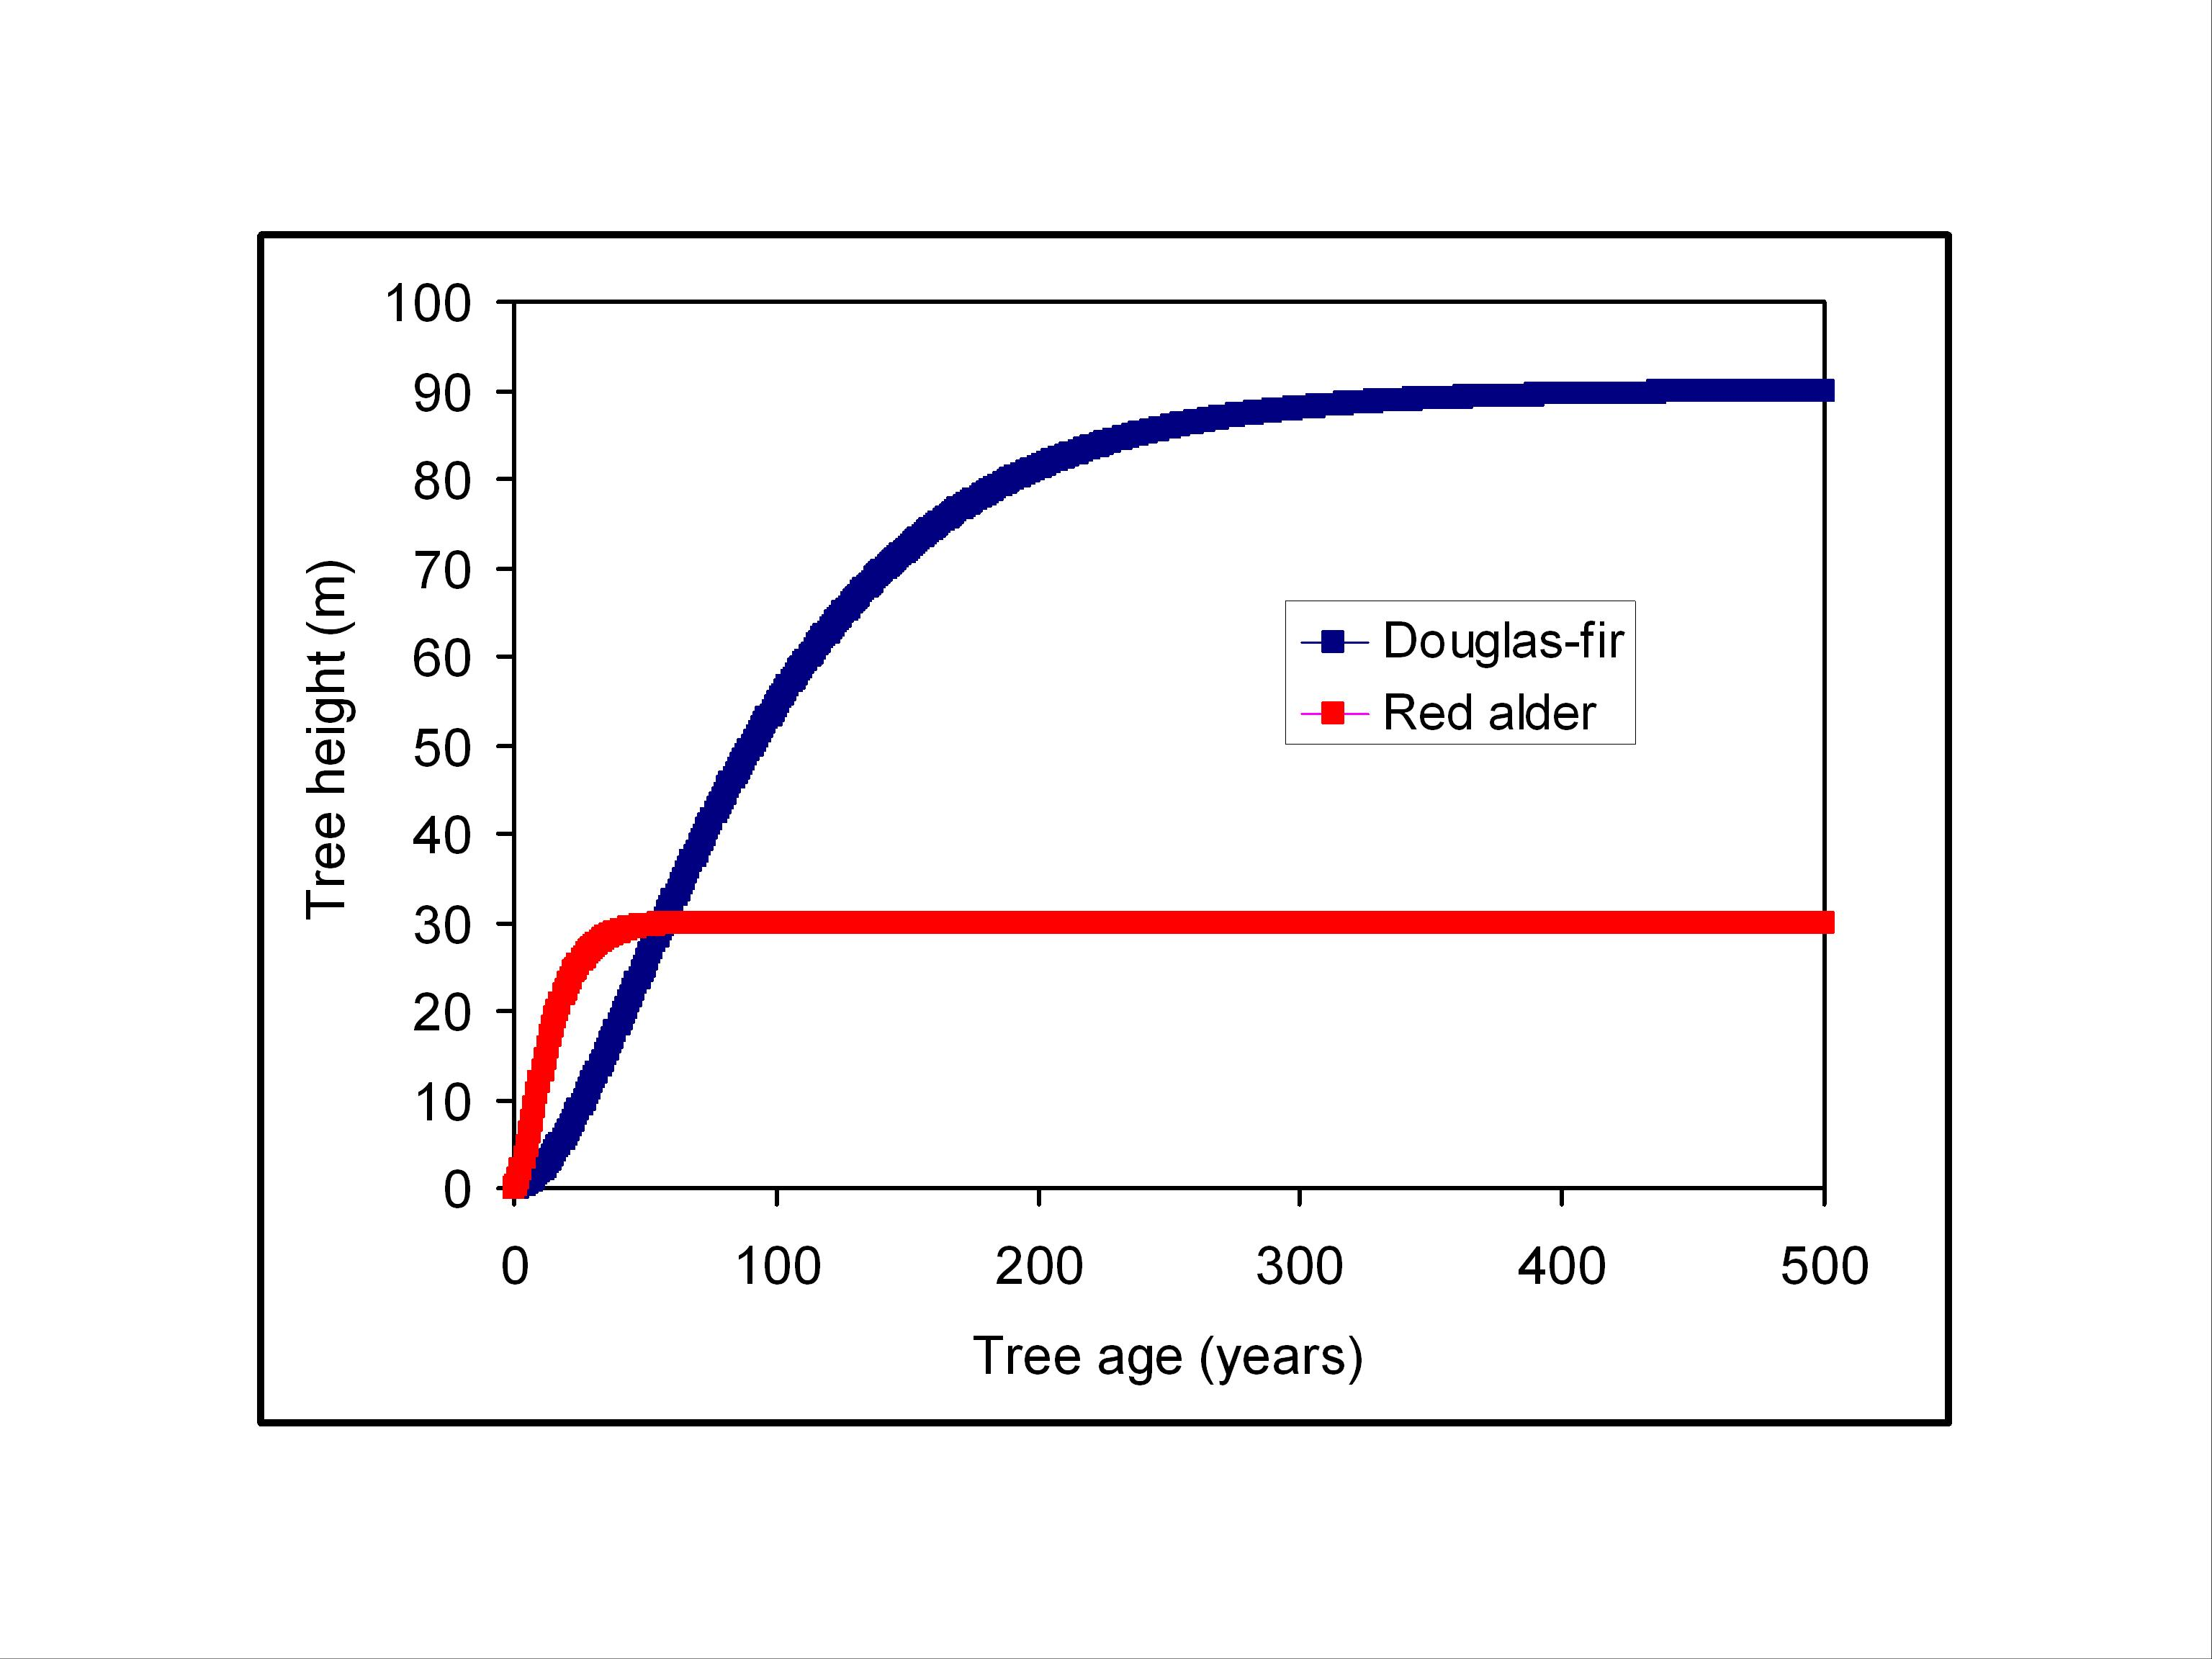

Figure 5-1. Examples of tree height as a function of cohort age.

Shading Function.

The purpose of this function is to determine the fraction of the sky that is obscured by surrounding entities (i.e., trees in cohorts, cohorts, stand grid cells). The angle (in radians) between the top of the tree layer in the entity of question and the adjacent entities is used to adjust the amount of light an entity receives (Figure 5-2). The term entities is used to refer to the locations at various levels of spatial detail (trees in cohorts, between cohorts, between stand grid cells). The angle is computed as:

ShadeAngle=arctan [(TotalHeightCell2-TotalHeightCell1)/CellDist]

where TotalHeightCell2 is the height of the tree layer in an adjacent entity, TotalHeightCell1 is the height of the tree layer in the entity in question and CellDist the distance from the center of one entity and another.

The angle of the sky open to light would therefore be:

OpenAngle=1.57 - ShadeAngle

For the within cohort level shading OpenAngle is rescaled to a fraction of the sky:

OpenFraction = OpenAngle /1.57

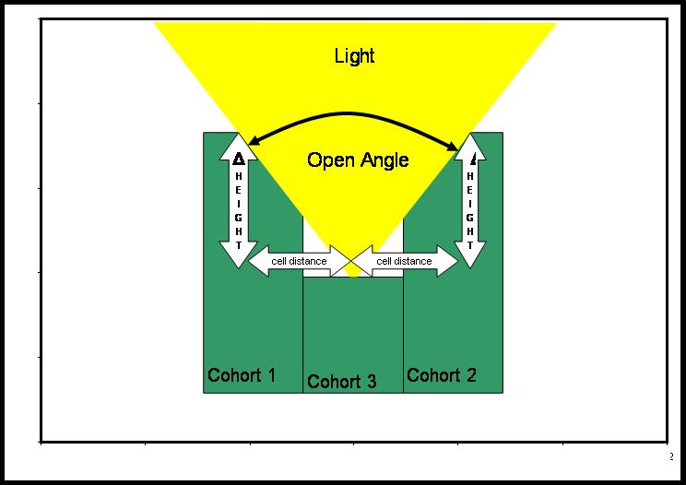

Figure 5-2. Relationship among cohort heights and amount of light available for growth.

For the between cohort level shading OpenAngle is similarly rescaled to a fraction of the sky:

OpenFraction = OpenAngle /1.57

For between stand grid cell shading the OpenAngle for the adjacent 8 stand grid cells are summed and divided by 12.5664 to estimate the fraction of the sky that is obscured by adjacent stand grid cells:

OpenFraction = Σ (OpenAngle /12.5664)

This number is then used to reduce the light that can enter an entity (i.e., tree in a cohort, cohort, or stand grid cell).

